Exercise 1: Mocking and Stubbing (MANDATORY)

MyServiceTest.java verifies that MyService.java correctly fetches data from a mocked ExternalApi.java using stubbing.

ExternalApi.java:

package com.example;

public interface ExternalApi {
String getData();
void reset();
}

MyService.java:
package com.example;

public class MyService {

private final ExternalApi api;

public MyService(ExternalApi api) {
this.api = api;
}
public String fetchData() {
return api.getData();
}
public void resetApi() {
api.reset();
}
}

MyServiceTest.java:
package com.example;

import org.junit.jupiter.api.Test;
import static org.mockito.Mockito.*;
import static org.junit.jupiter.api.Assertions.*;

public class MyServiceTest
{
@Test
public void testExternalApi()
{
ExternalApi mapi = mock(ExternalApi.class);
when(mapi.getData()).thenReturn("Mock Data");
MyService s = new MyService(mapi);
String res = s.fetchData();
assertEquals("Mock Data", res);
}
}

Output:
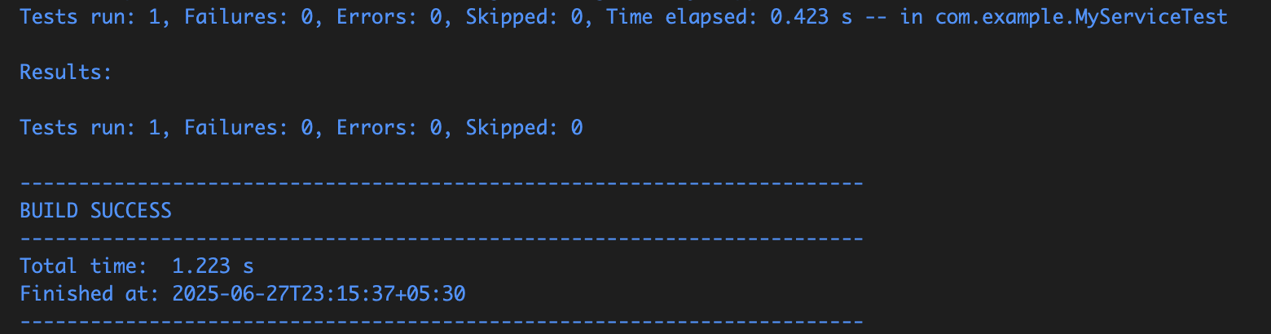

Exercise 2: Verifying Interactions (MANDATORY)

Verifies that the getData() method of the mocked ExternalApi is called when MyService.fetchData() is executed.

InteractionTest.java:
package com.example;

import org.junit.jupiter.api.Test;
import static org.mockito.Mockito.mock;
import static org.mockito.Mockito.verify;

public class InteractionTest {

@Test
public void testVerifyInteraction() {
ExternalApi mapi = mock(ExternalApi.class);
MyService s = new MyService(mapi);
s.fetchData();
verify(mapi).getData();
}
}

Output:
